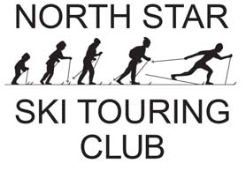
Membership Form

Name:  Additional Name (s)  Address  City State Zip  E-mail  Telephone ( ) -  Cell Phone ( ) - | I’m Interested in:  Singles  Lead Trips  Assist Trip Leaders  Trail Work  Family/Kids  Volunteer for Special Projects  Lead Day Hike/Bike/Ski  Other: Specify ____________
I do not want my phone # listed in the printed membership roster  I already receive the Wednesday Wanderers weekly e-mail, or  I wish to receive the Wednesday Wanderers weekly e-mail | I already receive the weekly e-Loype, or  I wish to receive the e-Loype weekly email

How did you learn about the North Star Ski Touring Club? _______________________________
Membership Type (please select one)  Newsletter via online only Newsletter via 1st Class Mail  Individual/Solo Family/Household Individual/Solo Family/Household  1 year $20 $20 $30 $30  2 years $38 $38 $58 $58  3 years $56 $56 $86 $86  Notes: The club newsletter (Loype) published quarterly and is available online to all members.  Membership fee covers all individuals at one address; it is not a per-person cost. |  | Payment Information  Membership Amount $  Trail Fund Donation $  Total Amount Enclosed $  We encourage a donation of $5 or more to help support trail improvements.  We encourage you to register and pay membership dues online at www.north-stars.org You can also mail this form and a check to:  NSSTC, Inc.  P.O. Box 4275  St. Paul, MN 55104-0275

